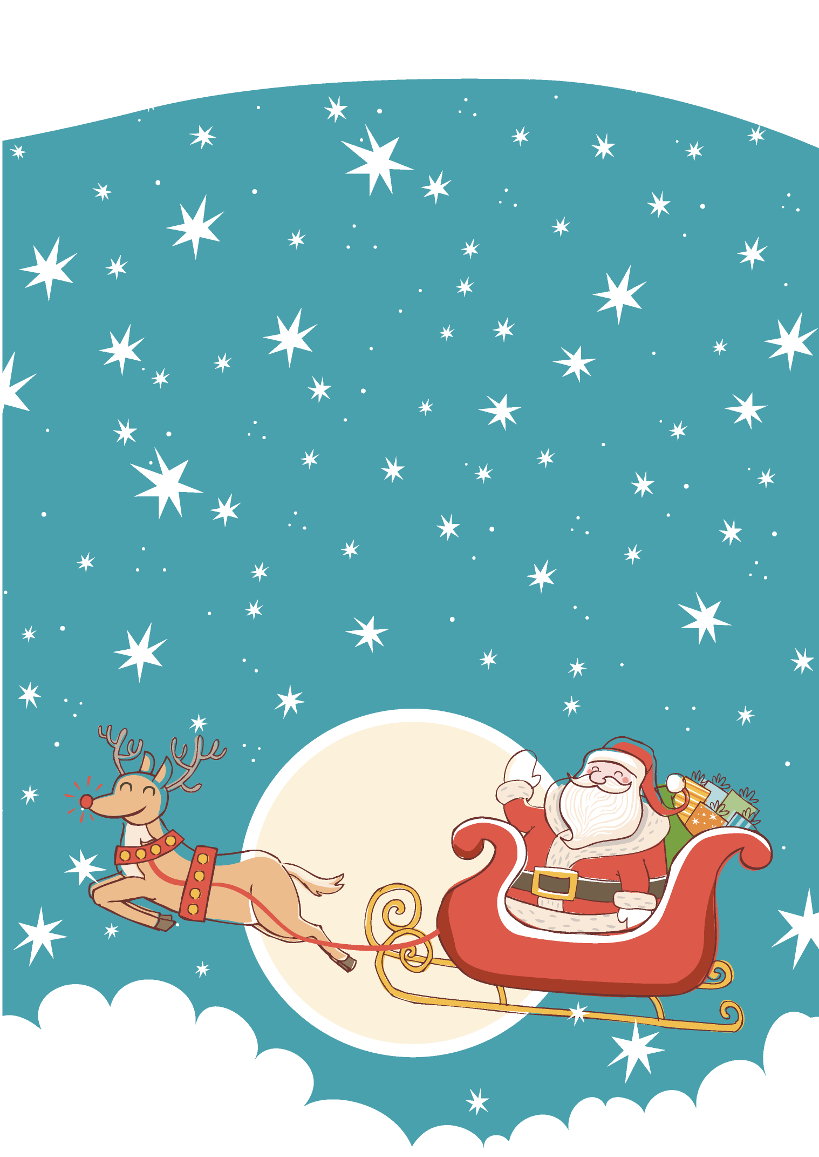  - Merry Christmas |  |  | 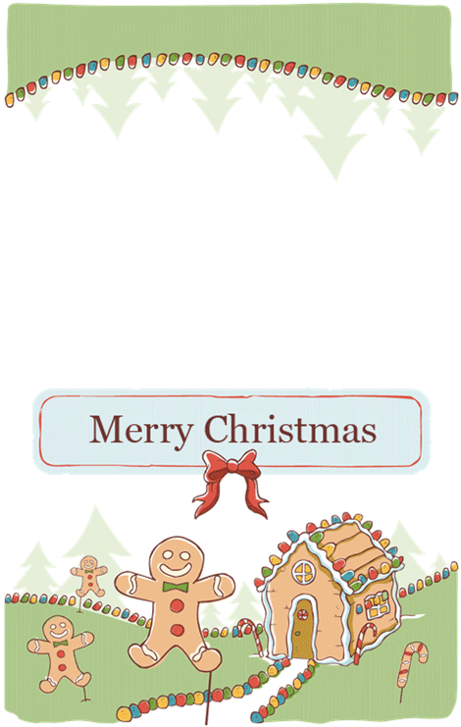

  
  Best wishes for the happiest of holidays!
  Best wishes for the happiest of holidays!
  

