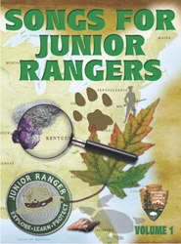 | Songs for Junior Rangers illustrated booklet of lyrics and photos  National Park Service has made music just for Junior Rangers  Junior Ranger Music CD  - Castillo De Lodo / Duration Time 2:19 This song was co-written by the Centennial Elementary School Cultural Music Club and Park Ranger Jeff Wolin. It is about Bent's Old Fort National Historic site.  - Explore, Learn, and Protect / Duration Time 3:28 The Junior Ranger Theme Song  - La Gran Garza Azul / Duration Time 3:47 A song about visiting the Everglades and watching the Great Blue Heron  - Four Presidents / Duration Time 2:27 A song about Mount Rushmore  - Spelunca Funka / Duration Time 3:07 A song about exploring caves  - Run Fish Run / Duration Time 2:37 A song about salmon and restoring rivers  - Down on the Mall / Duration Time 2:51 A song about the National Mall  - Skyscraper Plants / Duration Time 2:20 A song about the mighty redwoods  - New Orleans Jazz / Duration Time 3:37 A song about an American style of music  - Wapiti Hoppity / Duration Time 2:32 A song about elk  - Beach Party at High Altitude / Duration Time 3:11 A song about the Great Sand Dunes  - Thaddeus Kosciusko / Duration Time 2:53 A song about a Revolutionary War Hero

